**"Spread Smiles"**

A PROJECT REPORT SUBMITTED TO

**THE NATIONAL INSTITUTE OF ENGINEERING, MYSURU**

(An Autonomous Institute under VTU, Belagavi)



In partial fulfillment of the requirements for Project work (Minor Project – CS6C06),   
sixth semester

**Bachelor of Engineering**

**in**

**Computer Science and Engineering**

*Submitted by*

**Sowmya H L (4NI18CS092)**

**Sushmitha C G (4NI18CS098)**

**Uravakonda Kamal Mayukha (4NI18CS104)**

Under the Guidance of

Ms. M Prameela  
Assistant Professor, Dept. of CS&E

**DEPARTMENT OF COMPUTER SCIENCE AND ENGINEERING**

**THE NATIONAL INSTITUTE OF ENGINEERING**

Mysore-570 008

2020-2021

**DEPARTMENT OF COMPUTER SCIENCE AND ENGINEERING**

**THE NATIONAL INSTITUTE OF ENGINEERING**



***CERTIFICATE***

This is to certify that the project work entitled “**Spread Smiles**” is a work carried out by **Sowmya H L (4NI18CS092), Sushmitha C G (4NI18CS098) and Uravakonda Kamal Mayukha (4NI18CS104)** in partial fulfillment for the project work (Minor Project – CS6C06), sixth semester, Computer Science & Engineering, The National Institute of Engineering **(**Autonomous Institution under Visvesvaraya Technological University, Belagavi) during the academic year 2020-2021. It is certified that all corrections and suggestions indicated for the Internal Assessment have been incorporated in the report deposited in the department library. The project work report has been approved in partial fulfillment as per academic regulations of The National Institute of Engineering, Mysuru.

**Signature of the Internal Guides** **Signature of the HoD**

**______________ _______________**

Dr. V K Annapurna  
Professor and Head  
Dept. of CS&E  
NIE, Mysuru

Ms. Prameela M  
Assistant Professor, Dept. of CS&E

N

**Signature of the Examiners**

_________________

Name:  
Designation:

_________________

Name:  
Designation:

**ACKNOWLEDGEMENTS**

We would like to take this opportunity to express our profound gratitude to all those people who were directly or indirectly involved in the completion of this project. We thank each and every one who encouraged us in every possible way.

We would like to thank **Dr. N V Raghavendra**, Principal, NIE, Mysuru for letting us to be the part of this prestigious institution and letting us explore our abilities to the fullest.

We would like to extend our sincere gratitude to **Dr. Annapurna V K**, professor and HOD of ISE Department for being a source of inspiration and instilling an enthusiastic spirit in us throughout the process of project making.

We would like to express our heartfelt gratitude towards our project guide **Ms. M Prameela** for the constant guidance, valuable knowledge and experience.

**-Sowmya H L (4NI18CS092)**

**-Sushmitha C G (4NI18CS098)**

**- Uravakonda Kamal Mayukha (4NI18CS104)**

**Table of Contents**

**SL No. CHAPTER Page No.**

1. **INTRODUCTION 1**
   1. Introduction 1
   2. Objectives 1
2. **SYSTEM ANALYSIS 3**
   1. Existing system 3
   2. Proposed system 3
   3. System requirements 5
3. **SYSTEM DESIGN 8**
   1. System architecture 8
   2. Functional specification/ design methodology 8
   3. Broad design 8
   4. Data flow diagram 9
   5. Detailed design 11
   6. Module design 12
   7. Database design 13
4. **SYSTEM IMPLEMENTATION 15**
   1. Introduction 15
   2. Tools/ Languages used 16
5. **SYSTEM TESTING 18**
   1. Introduction 18
   2. Purpose of testing 18
   3. Types of testing 18
   4. Test Cases 20
6. **RESULTS 21**
   1. Home page - 1 21
   2. Home page - 2 21
   3. Home page - 3 22
   4. Donate food - 1 22
   5. Donate food - 1 23
   6. Donate medicines - 1 23
   7. Donate medicines - 2 24
   8. Need food 24
   9. Need medicine 25
   10. Volunteer registration 25
   11. Food deliveries 26
   12. Medicine deliveries 26
   13. Gallery – 1 27
   14. Gallery – 2 27
   15. About us – 1 28
   16. About us – 2 28
   17. About us – 3 29

**CONCLUSION 30**

**FUTURE ENHANCEMENTS 30**

**REFERENCES 31**

**List of figures**

**Figure No. DESCRIPTION Page No.**

1. Waterfall model 9
2. Data flow diagram (DFD) 11
3. Schema design 14

**Chapter 1**

**INTRODUCTION**

We all have been affected by the current COVID-19 pandemic. However, the impact of the pandemic and its consequences are felt differently depending on our status as individuals and as members of society. In these tough times, we thought of building a project which helps those people who are in need of essentials like food and medicines. The title of our project is “Spread Smiles”. This project aims to donate excess food and medicines. This project provides an online platform in the form of a website to connect the help providers and help seekers. This website reduces the efforts to provide or get help personally in offline mode.

These days, there are many COVID patients who are in need of food but on the other hand, a lot of food is being wasted in restaurants and households. Also, a lot of medicines is going unused in many households. Thus, our system provides a solution to this problem. We try to send excess food and medicines from our donors to our receivers.

Although there are similar websites to donate excess goods, most of them don’t allow individuals to donate small amount of goods. We try to display all donations on our website irrespective of their quantity and type. We display all the available donations at the specific time from which the help seekers can choose, based on their requirements. We also provide the volunteer facility if both the donor and receiver can not go to the destination and give/collect food.

**Objectives:**

* To provide more efficient and productive way of donating and receiving unused food and medicines.
* To avoid the not-so-quick process of reaching out for help offline.
* To tackle the problem of shortage of medicines, which arose due to the COVID-19 outbreak.
* To support non-profit organizations by donating medicines.
* To give a chance to the people to volunteer for our website and help others during these tough times.
* To give a chance to restaurants and also medical store to give away the excess and unused food or medicine, and hence preventing the wastage.

Thus, the goal of the Spread Smiles is to help the needy and poor in the most genuine and transparent way possible. As we are all in these tough times together, this project is our idea to encourage small donations and help the needy.

**Chapter 2**

**SYSTEM ANALYSIS**

**Existing system**:

There is a lot of food and medicines being wasted daily. Even though the owners want to donate the food, they do not know how to. There are some websites which accept food and medicine donations, but most of them do not allow small donations. Many of these websites do not provide delivery facility also.

**Drawbacks of existing system**:

* Existing websites do not accept small donations.
* Many steps to donate or receive help.
* Time consuming.
* No delivery option.

Our system will overcome all these flaws so that everyone can provide/receive the help they want.

**Proposed system**:

The main objective of this project is to donate excess food and the medicines which are unused. This application connects the people who have excess food and who are in need of food. Then the unused medicine can be donated to NGO for further utilization by a needy person. This project overcomes the rejection of small contribution of food and medicines, we collect all amounts of food from any individual. This project also contains delivery facility by the available volunteers, in the cases where donor and recipient are not able to contact each other.

In **user** interface, there will be 3 roles:

**Donor:** one who has food/medicines can post it in our website. In case of food donation, they have to provide some essential details like name, address, number of people it can serve and if they can deliver or not. In case of medicines, they have to provide details pertaining to medicine name, quantity and expiry date.

**Recipient:** the individuals/organizations who are in need of food can see the posts posted by donors and select any one of them. For food, anyone can apply regardless of individual or organization, but for medicines, only NGOs can apply.

**Volunteer**: If neither of them, i.e., the donor who has food can’t deliver and the recipient also can't go and collect it, these volunteers can take up this work by registering themselves. They are also responsible for collecting medicines that have been posted on the site on weekends and each week those unused medicines will be given to selected NGO by admin.

Coming to the User interface, this system provides user with numerous features like-

* Option to donate food.
* Option to donate medicines.
* Option to apply for available food donations.
* Option to apply for medicine donations for only NGOs.
* Option to volunteer for food collection or medicine collection.
* View the upcoming events in the home page.
* View the pictures taken during various events in the gallery page.

The details of donors and receivers will be saved in the database. The details of all the donations will also be saved for future references.

**Advantages:**

* Provides a responsive interface with many features.
* Establishing a connection between donors and receivers becomes effortless.
* Donors can donate and receivers can apply for available donations without any in person meeting.
* The volunteers also get an advantage with this digital platform.
* This gives an opportunity for the receivers to view the donations happening in and around the city.
* Communicating through website is more consistent than sending mails or making calls or meeting in person and hence far less time consuming.
* Without a website, many people can miss out on some donations hence resulting in the wastage of the food.

Food and medicine are the two most important necessities considering the ongoing pandemic. Communicating with a website is more consistent than manual meetings anytime. This food and medicine donation system is not only rewarding but it also helps the donor to quickly organize the donations and the receiver to get help in short interval of time. “Spread smiles” helps the users to check anything related to donations at any time. Manual work is reduced through this system. It’s also far less time consuming.

**System requirements:**

### INTRODUCTION:

Software Requirement Specification (SRS) is a description of a software system to be developed, laying out functional and non-functional requirements, and may include a set of use cases that describe interactions the users will have with the software. The purpose of this SRS document is to collect and analyze all assorted ideas that have come up to define the system, its requirements with respect to consumers and also to provide a detailed overview of our software product, its parameters and goals. SRS provides an overview of the entire system with purpose, scope, definitions, acronyms, abbreviations, references. The aim of this document is to gather and analyze and give an in-depth insight of the system by defining the problem statement in detail. Also, we shall predict and sort out how we hope this product will be used in order to gain a better understanding of the project, outline concepts that may be developed later, and document ideas that are being considered, but may be discarded as the product develops.

### 

### DEFINITION AND ABBREVIATION OF REQUIRED TOOLS:

* + - Donor: Donor is the one who donates the resources through the system.
    - Receiver/Recipient: Receiver/Recipient is the one who applies for donations through the system.
    - Volunteer: Volunteer is the one who provides his services in the form of delivery.
    - HTTP: Hypertext Transfer Protocol is a transaction-oriented client/server protocol between a web browser and a web server.
    - HTTPS: Secure Hypertext Transfer Protocol is a HTTP over SSL (Secure socket layer)
    - TCP/IP: Transmission Control Protocol / Internet Protocol, used to connect hosts on the Internet
    - HTML: Hypertext Mark-up Language used to design static web pages
      * KD : Knowledge Discovery
      * OS : Operating System
      * SRS : Software Requirement Specifications

### **Assumptions and Dependencies:**

#### 

#### **Assumptions:**

* It is assumed that the user has the knowledge of handling webpages.
* It is assumed that the system will be able to interface with a server in order to update automatically into the system.
* It is assumed that there will be seamless connection between database and applications.
* It is assumed that application included in the list will have the required information about the users with updated information.

#### **Dependencies:**

* Users should have knowledge in accessing the browser application
* We should maintain old data.

### 

### **Specific requirements:**

#### **External Interface Requirements:**

* Visual Studio
* Mongo DB server

#### 

#### **User Interfaces:**

* Startup interface where users can view information related to the upcoming events, various options to donate, seek help, volunteer.
* Interface for the users to donate food.
* Interface for the users to donate medicine.
* Interface for the users to view available food donations.
* Interface for the NGOs/Organizations to apply for medicines.
* Interface for the volunteer to view the live food deliveries and medicine deliveries to collect.

#### **Hardware Interfaces:**

Hardware required to develop the software is as listed below:

* Processor : Dual core or above
* RAM : 2GB Onwards
* Hard disk space : 20GB Onwards
* Speed : 1.3GHz +
* Standard Internet Connection

#### **Software Interfaces:**

Software required in development is as listed below:

* Operating System : Windows version
* Preferred IDE : Visual Studio Code
* Front End : HTML, CSS, JavaScript, Bootstrap
* Back End : Node.js, Express, Mongo dB
* Programming Language : JavaScript

### 

### **Performance requirements:**

In systems engineering and requirements engineering, non-functional requirements are requirements which specify criteria that can be used to judge the operation of a system, rather than specific behaviors. This should be contrasted with functional requirements that specify specific behavior or functions. Typical non-functional requirements are Reliability, Scalability, Performance, Usability, Maintainability, Portability and Cost. Other terms for non-functional requirements are "quality attributes" and "quality of service requirements".

**Chapter 3**

**SYSTEM DESIGN**

**System Architecture:**

**Introduction:**

The purpose of the design phase is to plan a solution of the problem specified by the requirements document. This phase is the first step in moving from the problem domain to the solution domain. In other words, starting with what is needed; design takes us toward how to satisfy the needs. The design of a system is perhaps the most critical factor affecting the quality of the software; it has a major impact on the later phases particularly testing and maintenance.

### 

### **FUNCTIONAL SPECIFICATION/DESIGN METHODOLOGY:**

* + - System is used to identify the donations available in the city.
    - System can be used to request for the available donations.
    - System is be used to find volunteers who are willing to help.
    - System contains 4 actors namely administrator, donor, recipient, volunteer.
    - System makes use of the available data about the donations and helps to connect donors to receiver and also volunteers to donations which require to be delivered.

### **BROAD DESIGN:**

According to Software Engineering the approach adopted to develop this project is the Iterative waterfall Model. The iterative waterfall Model is a systematic approach that begins at the feasibility study phase and progress through analysis, design, coding, testing, integration and maintenance. Feedback paths are there in each phase to its preceding phase as show in the figure to allow the correction of the errors committed during a phase that are detected in later phase.

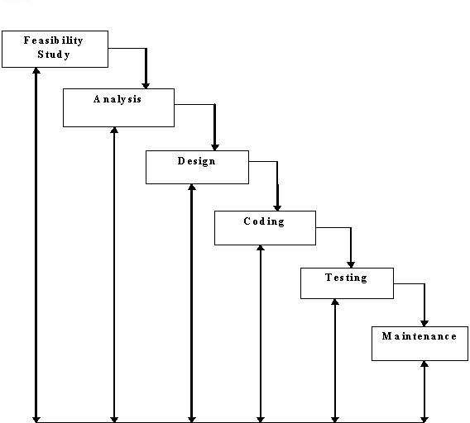

Fig.1: Waterfall model

### 

### **DATA FLOW DIAGRAM:**

A data flow diagram (DFD) is a graphical representation of the "flow" of data through an [information system.](http://en.wikipedia.org/wiki/Information_system) DFDs can also be used for the [visualization](http://en.wikipedia.org/wiki/Data_visualization) of [data](http://en.wikipedia.org/wiki/Data_processing) [processing](http://en.wikipedia.org/wiki/Data_processing) (structured design). On a DFD, data items flow from an external data source or an internal data store to an internal data store or an external data sink, via an internal process. A DFD provides no information about the timing of processes, or about whether processes will operate in sequence or in parallel. It is therefore quite different from a [flowchart,](http://en.wikipedia.org/wiki/Flowchart) which shows the flow of control through an algorithm, allowing a reader to determine what operations will be performed, in what order, and under what circumstances, but not what kinds of data will be input to and output from the system, nor where the data will come from and go to, nor where the data will be stored (all of which are shown on a DFD).

#### **Symbols used in DFD’s:**

1. **Processes:**

A process transforms data values. The lowest processes are our functions without side effects.

#### **Data Flows:**

A data flow connects the output of an object or process to the input of another object or process. It represents the intermediate data values within the computation. It is draws as an arrow between the procedure and the consumer of the data value. The arrow is labeled with the description of the data, usually its name or type.

#### **Actors:**

An actor is an active object that drives the data flow graph by producing or consuming values. Actors are attached to the inputs and the outputs of a dataflow graph. In sense, the actors lie on the boundary of the flow graph but terminate the flow of data as sources and sinks of data, and so are sometimes called terminators.

#### **Data Store:**

A data store is a passive object within a data flow diagram that stores data for later access. Unlike an actor, a data store does not generate any operations on its own but merely responds to requests to store and access data.

#### **Level 1 (high level diagram):**

This level (level 1) shows all processes at the first level of numbering, data stores, external entities and the data flows between them. The purpose of this level is to show the major and high-level processes of the system and their interrelation. A process model will have one, and only one, level-1 diagram. A level-1 diagram must be balanced with its parent context level diagram, i.e. there must be the same external entities and the same data flows, these can be broken down to more detail in the level1.

Figure 1 shows the detailed data flow. Apart from viewing basic details, public doesn’t involve in many functionalities. So, data flow diagram of Use is only shown. A User after successful login is provided with functionalities like viewing upcoming sports events, view mentors for different sports, view shortlisted students for upcoming events and view gallery. Actions performed by the actors are constantly updated to the respective database as shown.

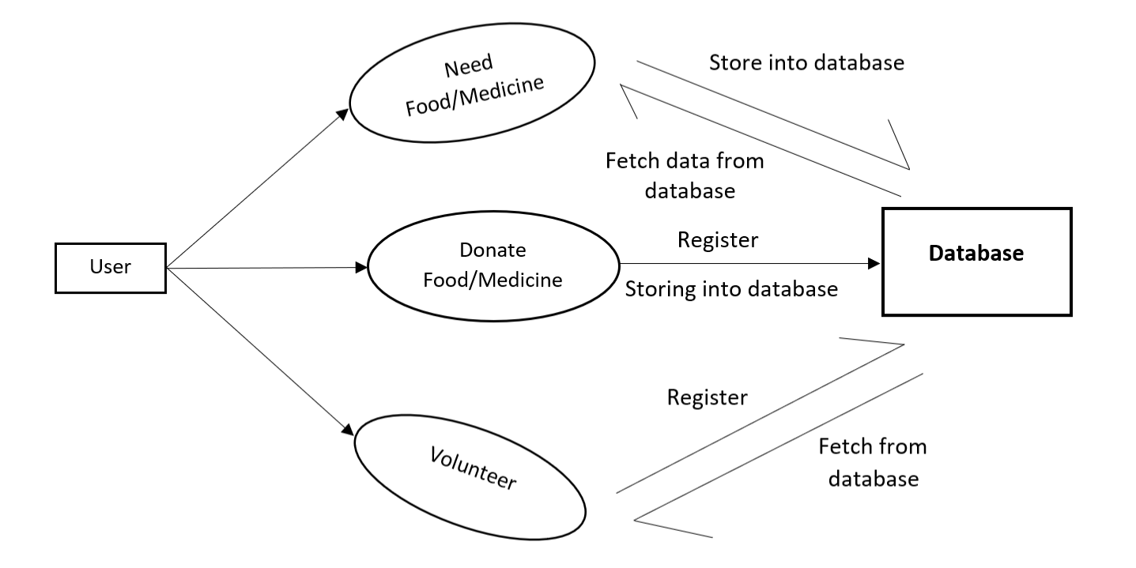

Fig.1: Data flow diagram (User)

### **DETAILED DESIGN:**

#### **Introduction:**

Systems design is the process of defining the architecture, modules, interfaces, and data for a system to satisfy specified requirements. Systems design could be seen as the application of systems theory to product development.

#### **Architecture of the System:**

#### **Three tier Architecture:**

Three-tier architecture is a client-server architecture in which the functional process logic, data access, computer data storage and user interface are developed and maintained as independent modules on separate platforms.

#### **The Data Layer:**

The key component to most applications is the data. The data has to be served to the presentation layer somehow. The data layer is a separate component (often setup as a separate single or group of projects in a .NET solution), whose sole purpose is to serve up the data from the database and return it to the caller. Through this approach, data can be logically reused, meaning that a portion of an application reusing the same query can make a call to one data layer method, instead of embedding the query multiple times. This is generally more maintainable.

#### **Business Layer:**

Though a web site could talk to the data access layer directly, it usually goes through another layer called the business layer. The business layer is vital in that it validates the input conditions before calling a method from the data layer. This ensures the data input is correct before proceeding, and can often ensure that the outputs are correct as well. This validation of input is called business rules, meaning the rules that the business layer uses to make “judgments” about the data. One of the best reasons for reusing logic is that applications that start off small usually grow in functionality. The business layer helps move logic to a central layer for “maximum reusability.”

#### **Presentation Layer:**

The website or windows forms application (the UI for the project) is called the presentation layer. The presentation layer is the most important layer simply because it’s the one that everyone sees and uses. Even with a well-structured business and data layer, if the presentation layer is designed poorly, this gives the users a poor view of the [system.](http://dotnetslackers.com/articles/net/IntroductionTo3TierArchitecture.aspx#%23)

The **presentation tier** contains the UI (User Interface) elements of the site, and includes all the logic that managers the interaction between the visitor and the client’s business.

The **business tier** receives requests from the presentation tier and returns a result to the presentation tier depending on the business logic it contains.

The **data tier** is responsible for storing the application’s data and sending it to the business tier when requested.

### **MODULE DESIGN:**

#### This application mainly consists of 3 actors:

1. **Donor**

Donor is the one who makes donations through the website. He is responsible for uploading all the required details about their donation.

1. **Recipient/ Receiver**

Recipient/ Receiver is the one who applies for the available donations according to his/her requirements.

1. **Volunteer**

Volunteer is the one who provides the delivery help for the appropriate donations. He is responsible for collecting the goods and delivering it to the corresponding receiver.

### **DATABASE DESIGN:**

**Database:**

**MongoDB** is a document-oriented NoSQL database used for high volume data storage. Instead of using tables and rows as in the traditional relational databases, MongoDB makes use of collections and documents. Documents consist of key-value pairs which are the basic unit of data in MongoDB. Collections contain sets of documents and function which is the equivalent of relational database tables. MongoDB is a database which came into light around the mid-2000s.

MongoDB is a **distributed database at its core**, so high availability, horizontal scaling, and geographic distribution are built in and easy and free to use. It comes with the scalability and flexibility that you want with the querying and indexing that you need. MongoDB **stores data in flexible, JSON-like documents**, meaning fields can vary from document to document and data structure can be changed over time. The document model **maps to the objects in your application code**, making data easy to work with. **Ad hoc queries, indexing, and real time aggregation** provide powerful ways to access and analyze your data.

The data model available within MongoDB allows you to represent hierarchical relationships, to store arrays, and other more complex structures more easily. MongoDB uses the concept of shading to scale horizontally by splitting data across multiple MongoDB instances. MongoDB can run over multiple servers, balancing the load and/or duplicating data to keep the system up and running in case of hardware failure.

In this project, we have used mainly five collections as shown in the Schema Design. We’ve created a collection for storing food-donor details, medicine-donor details, food-receiver details, medicine-receiver details and volunteer details. The Schema Design in the next section will provide a better view.

**Schema Design:**

MongoDB schema design is the most critical part of deploying a scalable, fast and affordable database. It works differently than relational schema design. It provides two types of data models: — Embedded data model and Normalized data model. Based on the requirement, you can use either of the models while preparing your document. While designing schema, one should consider good query performance and reasonable amount of hardware. The following figure shows Schema Design of our project.

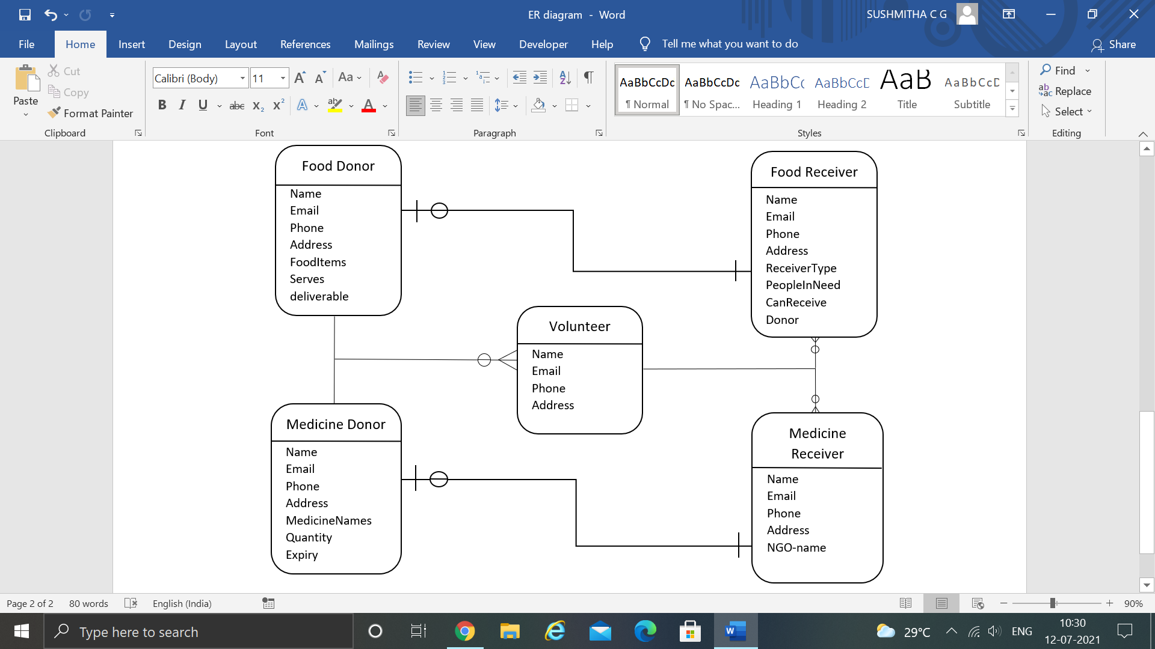

Fig.7: Schema Design

**Chapter 4**

**System Implementation**

**Introduction:**

This web application is implemented using object-based programming language. Object oriented programming is an approach that provides a way of modularizing programs by creating partitioned memory area for both data and functions that can be used as templates for creating copies of such modules on demand.

This project is implemented using three tier architecture which is a standard architecture for designing software. Here the project is divided into three layers as shown below.

**Presentation Layer:**

Presentation Layer is the front-end part (GUI) which invokes the Business logic through button click or page load event or Selected Index Change event of the dropdown list.

**Business Logic Layer:**

Business Logic Layer contains the class members and member functions. An object for Business logic class is created and this object will invoke the methods created in data layer for performing database operations.

**Data Layer:**

Data Layer is the basic layer which is related to the database of the project. It contains the list of queries related to the project which aid in performing various database operations.

Here HTML, CSS, JavaScript, bootstrap is used in the presentation layer(front-end), JavaScript is used in the Business logic layer, Mongo DB server (database) is used as the back-end.

**Program/Module Specification**

This Food & Medicine donation system is a website which contains the details of hosted donation in and around the city. This website gives an opportunity to host available donations, apply for the available donations, volunteer to deliver the donations etc.

**Functions:**

* Option to donate food.
* Option to donate medicines.
* Option to apply for available food donations.
* Option to apply for medicine donations for only NGOs.
* Option to volunteer for food collection or medicine collection.
* View the upcoming events in the home page.
* View the pictures taken during various events in the gallery page.

**Tools/Languages Used:**

**VS Code:**

Visual Studio Code is a streamlined code editor with support for development operations like debugging, task running, and version control. It aims to provide just the tools a developer needs for a quick code-build-debug cycle and leaves more complex workflows to fuller featured IDEs, such as Visual Studio IDE.

**Node.js**:

Node.js is an open-source and cross-platform JavaScript runtime environment. It is a popular tool for almost any kind of project. Node.js runs the V8 JavaScript engine, the core of Google Chrome, outside of the browser. This allows Node.js to be very performant.

A Node.js app runs in a single process, without creating a new thread for every request. Node.js provides a set of asynchronous I/O primitives in its standard library that prevent JavaScript code from blocking and generally, libraries in Node.js are written using non-blocking paradigms, making blocking behaviour the exception rather than the norm.

**JavaScript:**

JavaScript is a dynamic computer programming language. It is lightweight and most commonly used as a part of web pages, whose implementation allow client-side script to interact with the user and make dynamic pages. It is an interpreted programming language with object-oriented capabilities.

* to see if they have forgotten to enter something
* Immediate feedback to the visitors - They doesn’t have to wait for a page reload Increased interactivity - You can create interfaces that react when the user hovers over them with a mouse or activates them via the keyboard.
* Richer interfaces – You can use JavaScript to include such items as drag and drop components and sliders to give a rich interface to your site visitors.

**MongoDB:**

**MongoDB** is a document-oriented NoSQL database used for high volume data storage. Instead of using tables and rows as in the traditional relational databases, MongoDB makes use of collections and documents. Documents consist of key-value pairs which are the basic unit of data in MongoDB. Collections contain sets of documents and function which is the equivalent of relational database tables. MongoDB is a database which came into light around the mid-2000s.

MongoDB is a **distributed database at its core**, so high availability, horizontal scaling, and geographic distribution are built in and easy and free to use. It comes with the scalability and flexibility that you want with the querying and indexing that you need. MongoDB **stores data in flexible, JSON-like documents**, meaning fields can vary from document to document and data structure can be changed over time. The document model **maps to the objects in your application code**, making data easy to work with. **Ad hoc queries, indexing, and real time aggregation** provide powerful ways to access and analyze your data.

**Chapter 5**

**System Testing**

**Introduction:**

Testing is a process of executing a program to ensure that defined input will produce actual results that agree with required outputs. In developing a software project, error can be initiated at any stage during the development. For each phase of the software development cycle there are different techniques for detecting and elimination errors that originate in that phase. However some errors will reflect in the code. Testing performs a very crucial role for quality assurance and for ensuring the reliabilities of the software. The quality of the system depends on its design, development, testing and implementation. Weaknesses in any of these areas will seriously affect the quality and therefore value of the system to its users. Once the code has been generated, testing of the modules begins implementation ends with formal tests.

**Purpose of Testing:**

Testing accomplishes a variety of things, but most importantly it measures the quality of the software we are developing. This view presupposes there are defects in the software waiting to be discovered and this view is rarely disproved or even disputed. Several factors contribute to the importance of making testing a high priority of any software development effort. These include:

* Reducing the cost of developing the program.
* Ensuring that the application behaves exactly as we explain to the user for the vast majority of programs, unpredictability is the least desirable consequences of using an application.

**Types of Testing:**

**Unit Testing:**

Unit testing focuses verification on the smallest unit of software design, the software component or module. Using the component level design description as a guide, important control paths are tested to uncover errors within the boundary of the module. The unit testing is a white box-oriented testing.

First of all the module interface is tested to ensure that the information properly flows into and out of the program until under test. Then the local data structure is tested to ensure the data stored temporarily maintains its integrity during all steps in an execution. Boundary conditions are tested to ensure that the module operates properly at boundaries established to limit or restrict processing. All independent paths through the control structure are exercised to ensure that all statements in a module have been executed at least once. And finally, all errors handling paths are tested. In this project the testing is done according to bottom-up approach. Starting with smallest and lowest level modules and processing one at a time. For each module a driver and corresponding stubs were also written. If any errors found they were corrected immediately and the unit was tested again.

**Integration Testing:**

Integration testing is a logical extension of unit testing. In its simplest form, two units that have already been tested are combined into a component and the interface between them is tested. A component, in this sense, refers to an integrated aggregate of more than one unit. The idea is to test combinations of pieces and eventually expand the process to test your modules with those of other groups. Eventually all the modules making up a process are tested together. Any errors discovered when combining units are likely related to the interface between units. This method reduces the number of possibilities to a far simpler level of analysis.

In this software, the bottom-up integration testing approached has been used, starting with the smallest and lowest level modules and proceeding one at a time. For each module the tests were conducted and the results were noted down.

**User Testing:**

User Testing is nothing but the test of the software by the users themselves with live data being fed to the system. This helps in building really robust system. This helps in building really robust system. User testing in this system has been done extensively ascertain the results.

**Walkthroughs, Reviews and Demos:**

Sometimes known as the informal peer group review, walkthroughs are one of a handful of techniques that make a big difference to the chances of success in a software project. The aim of a walkthrough is to improve the quality of a piece of work by discovering potential problems. A walkthrough, when done properly, is seen as a positive contribution to the producer and his or her work; it is not seen as criticism or a negative activity or a threat. Plenty of “Reviews, Walkthroughs or Demos to the guides are done regularly in various meetings”. This helped ascertaining the work being done, whether it is going in a correct way or not, and it also helped in lot of it continues improvement in the features of the system.

**Test cases:**

| **SL No.** | **Test Cases** | **Expected**  **Result** | **Actual Result** | **Status of**  **Execution**  **Pass/Fail** |
| --- | --- | --- | --- | --- |
| TC01 | Execute/run the application | Application should run without any interrupts | Application is executing properly | Pass |
| TC02 | Storing the data of the food and medicine donations | The details of the donations submitted by the donors should be saved in the database | Donation details are successfully saved in the database | Pass |
| TC03 | Storing the data of the receivers who applied for a donation | The details of the food or medicine applications should be stored in the database | Data submitted by the receiver is successfully saved in the database | Pass |
| TC04 | Matching the donors who can’t deliver the food and receivers who can’t collect the food and displaying them in the volunteer page | If both the donor and receiver of a particular donation cannot deliver/collect the food, such donations should be displayed in the volunteer page | The donors and receivers are successfully matched and displayed in the volunteer page | Pass |

**Chapter 6**

**Results**

**6.1 Home page-1**

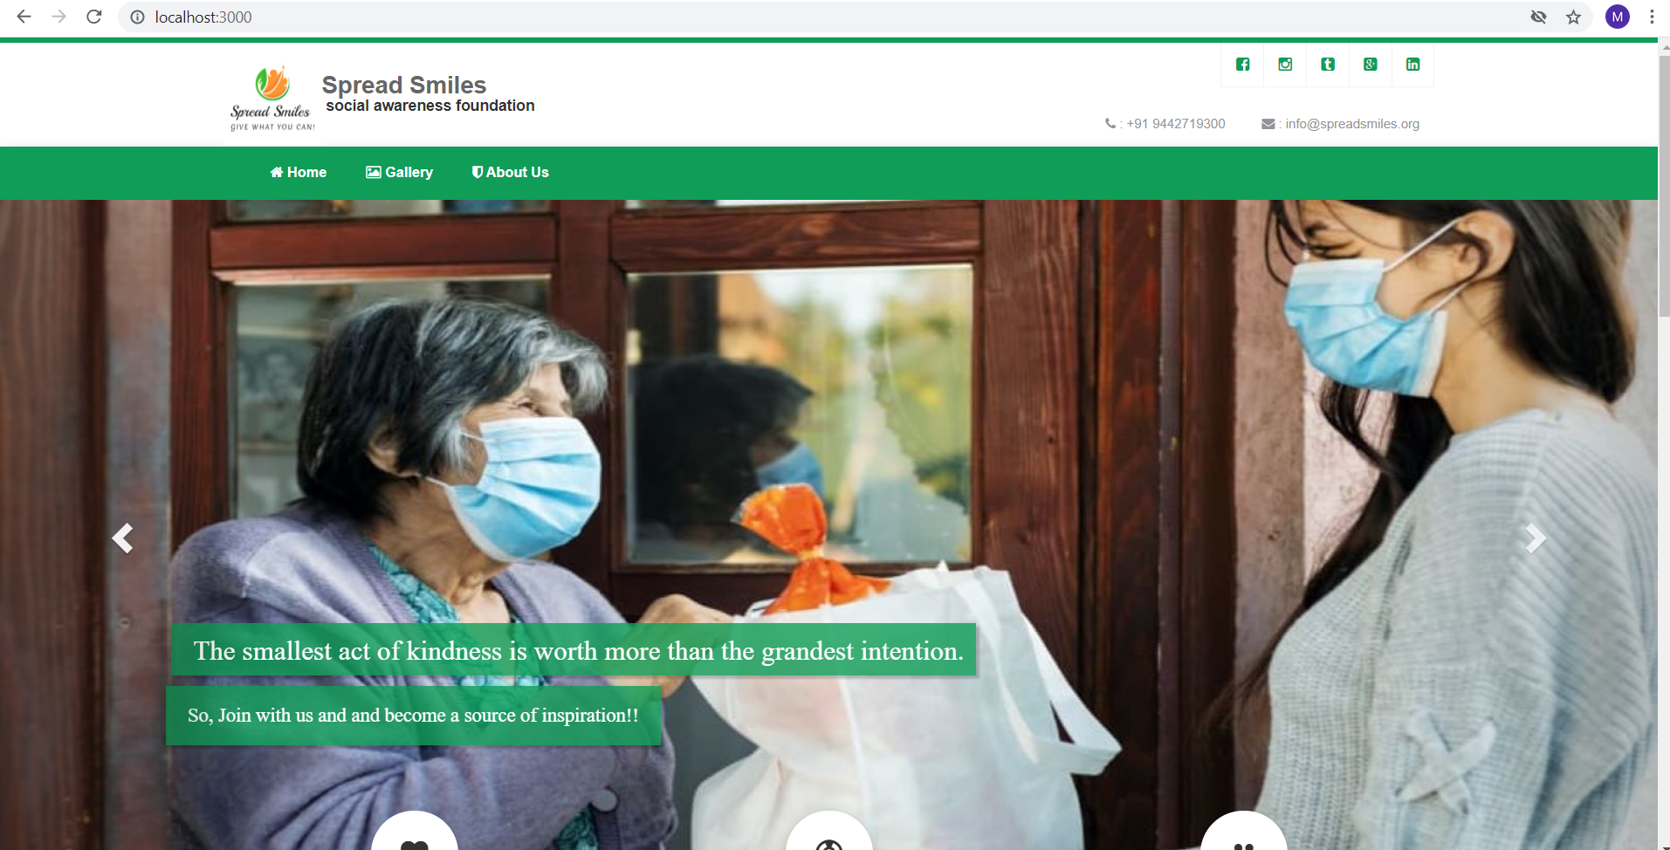

**6.2 Home page-2**

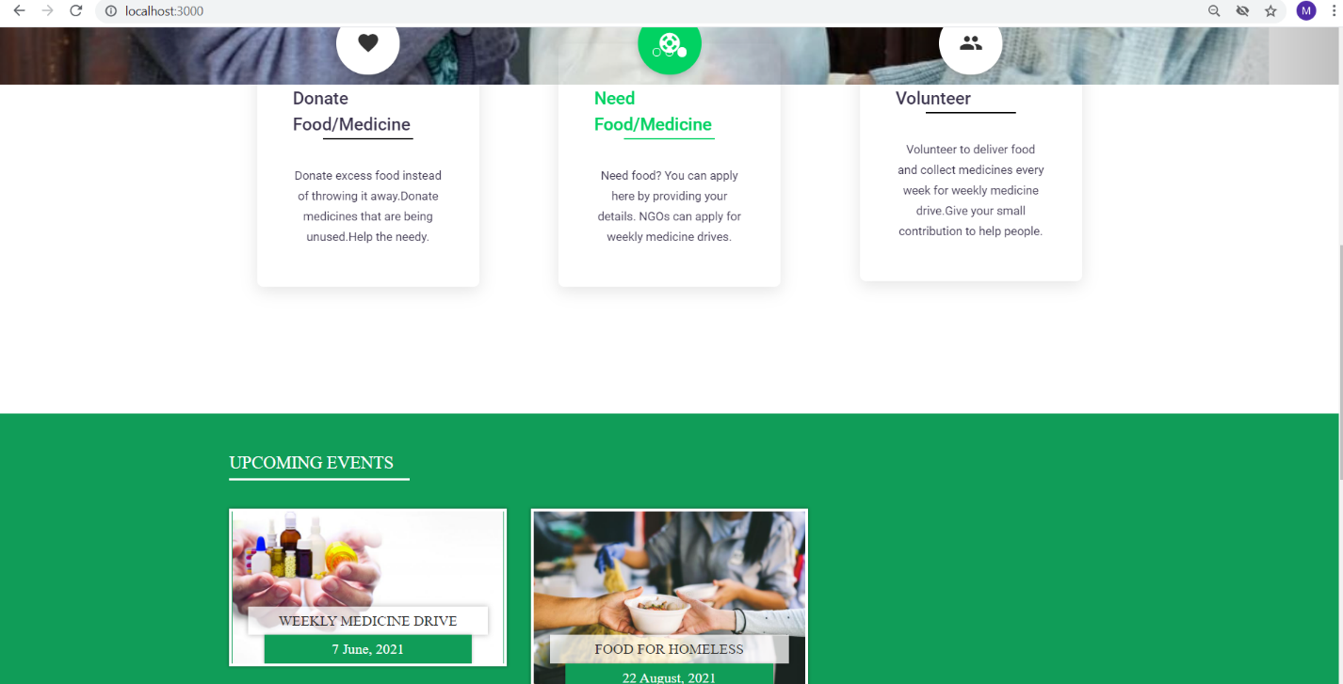

**6.3 Home page-3**

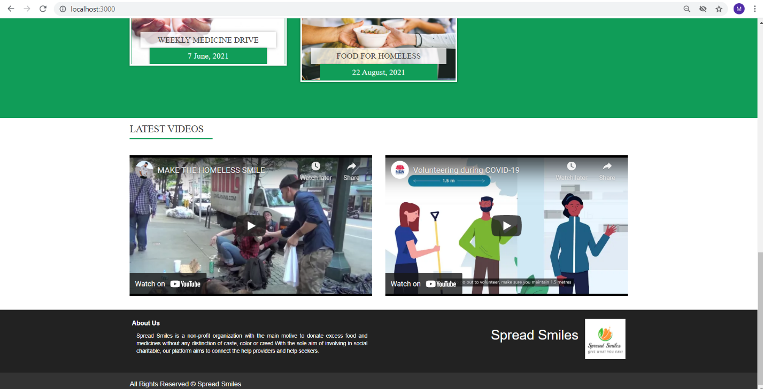

**6.4 Donate food-1**

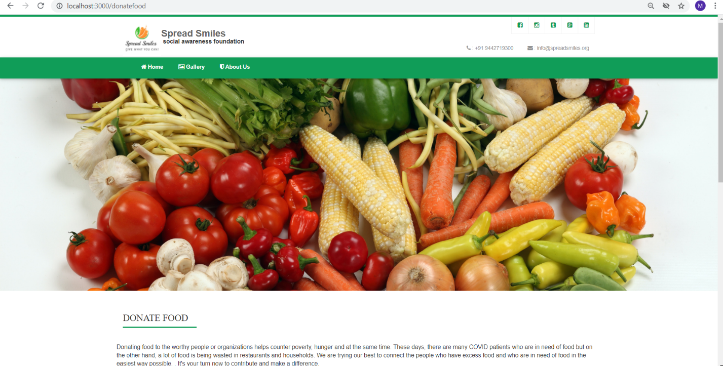

**6.5 Donate food-2**

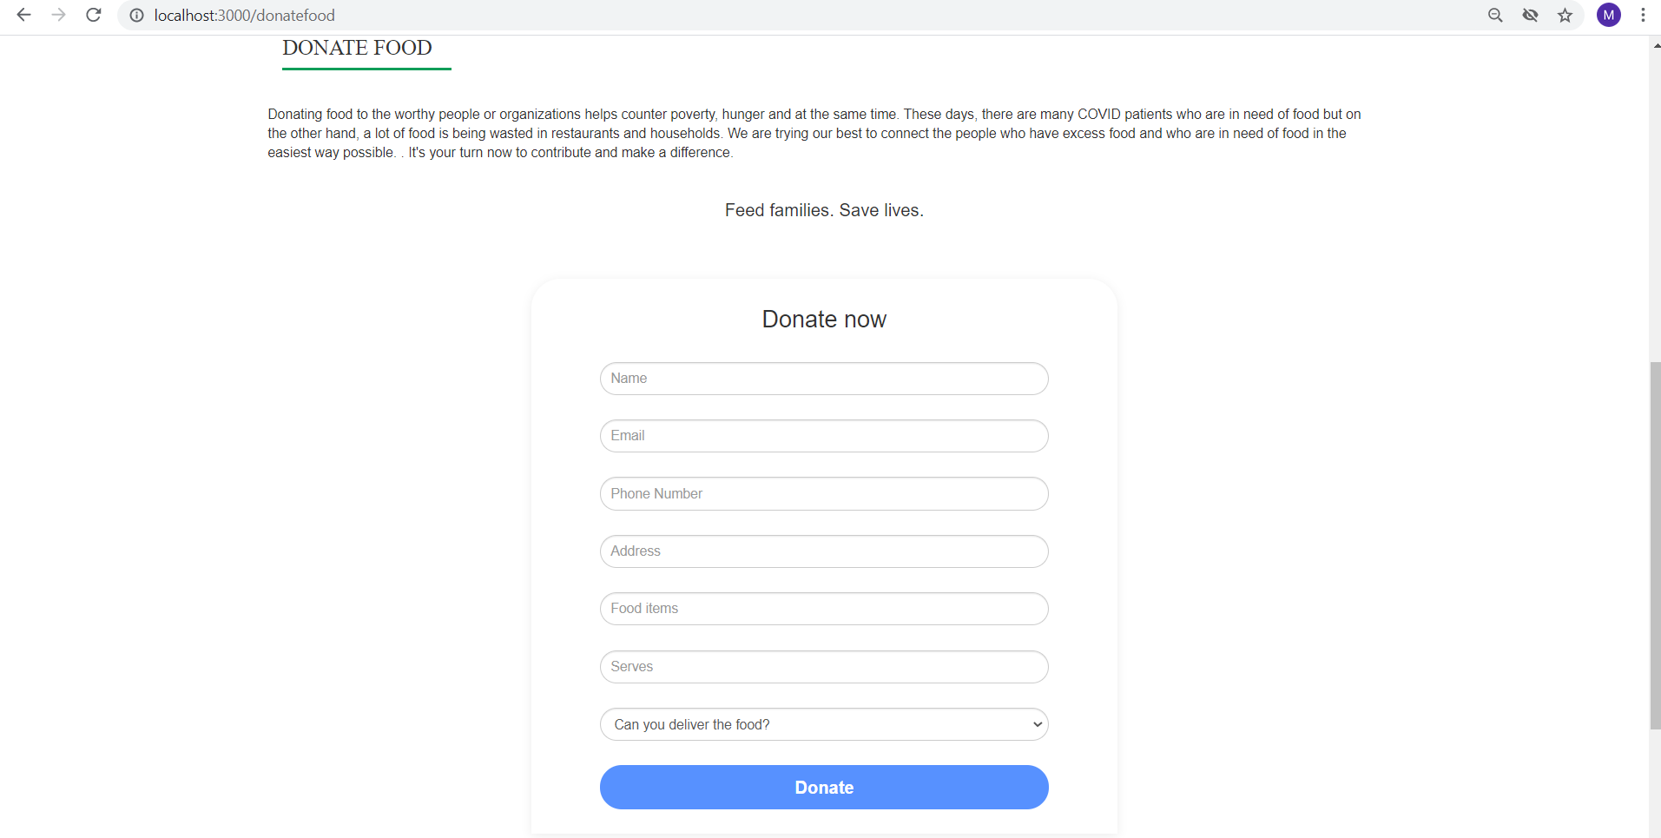

**6.6 Donate medicines-1**

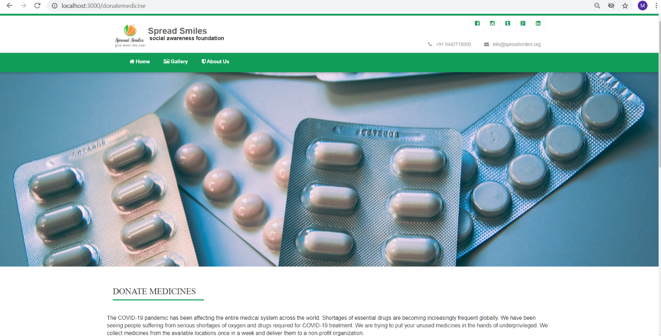

**6.7 Donate medicines-2**

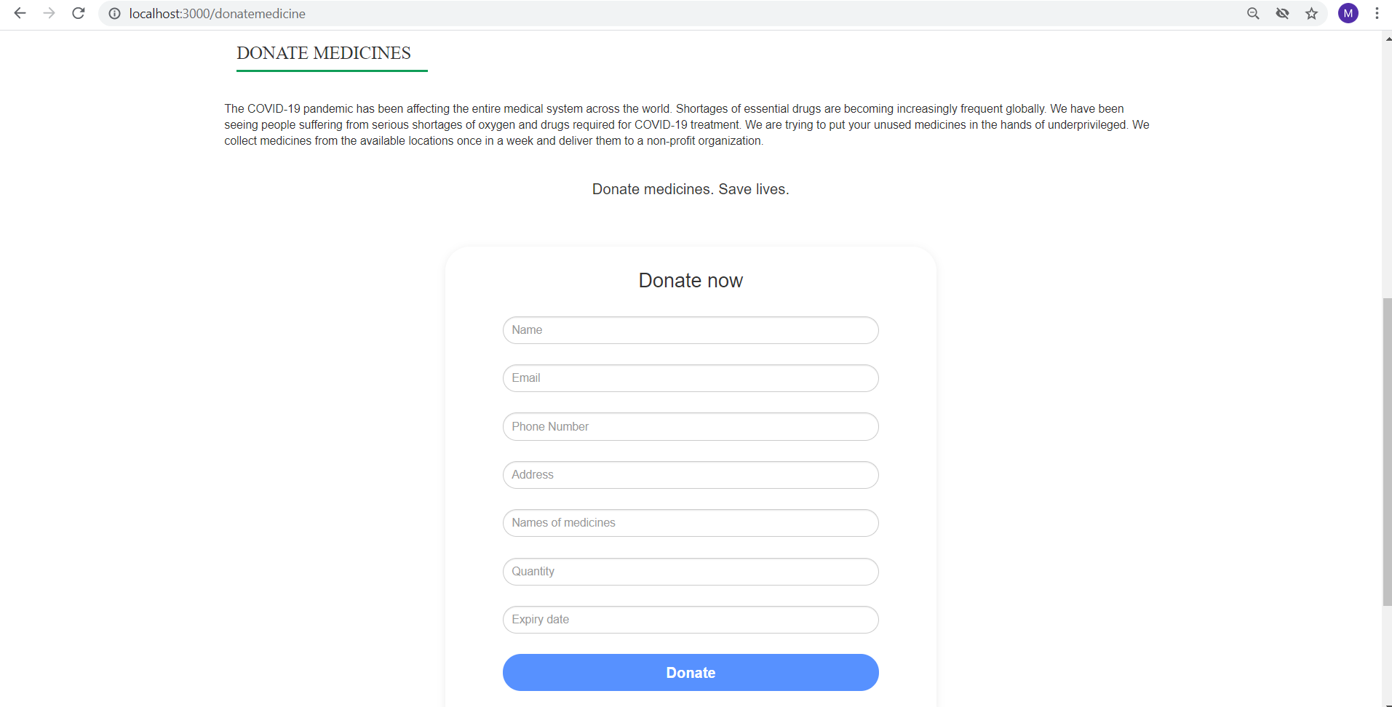

**6.8 Need food**

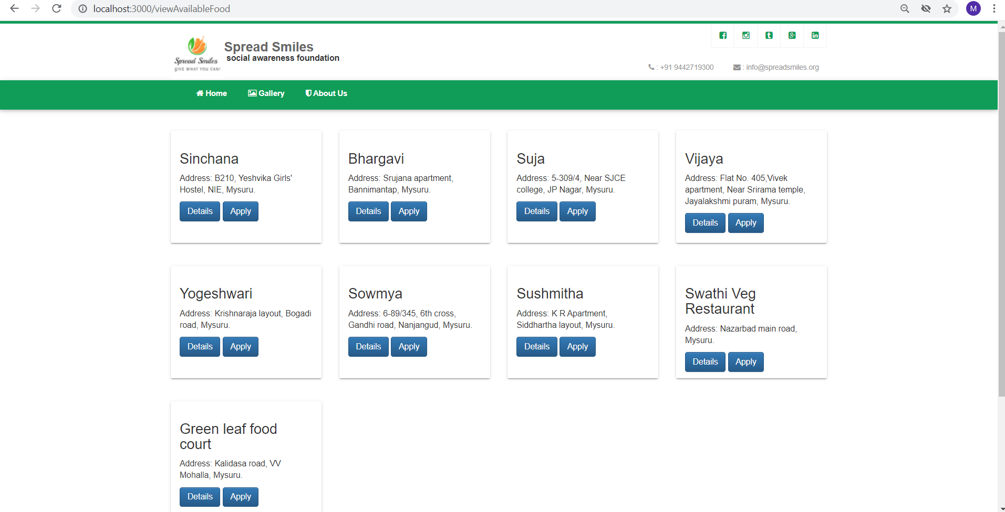

**6.9 Need medicines**

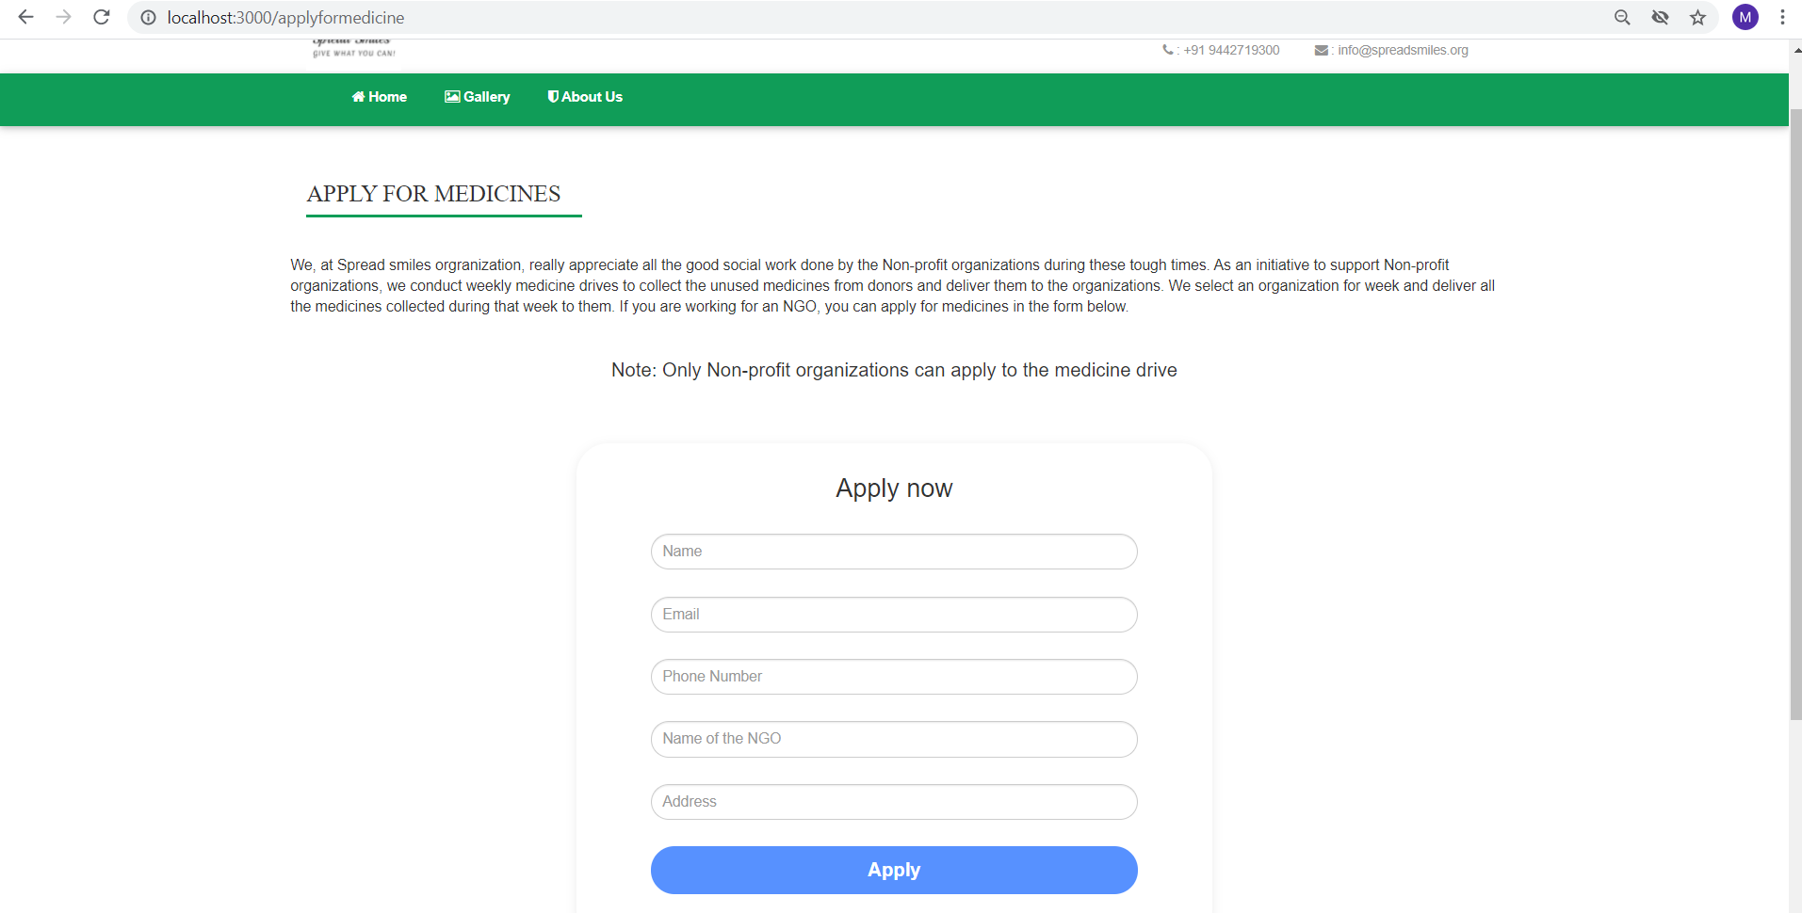

**6.10 Volunteer registration**

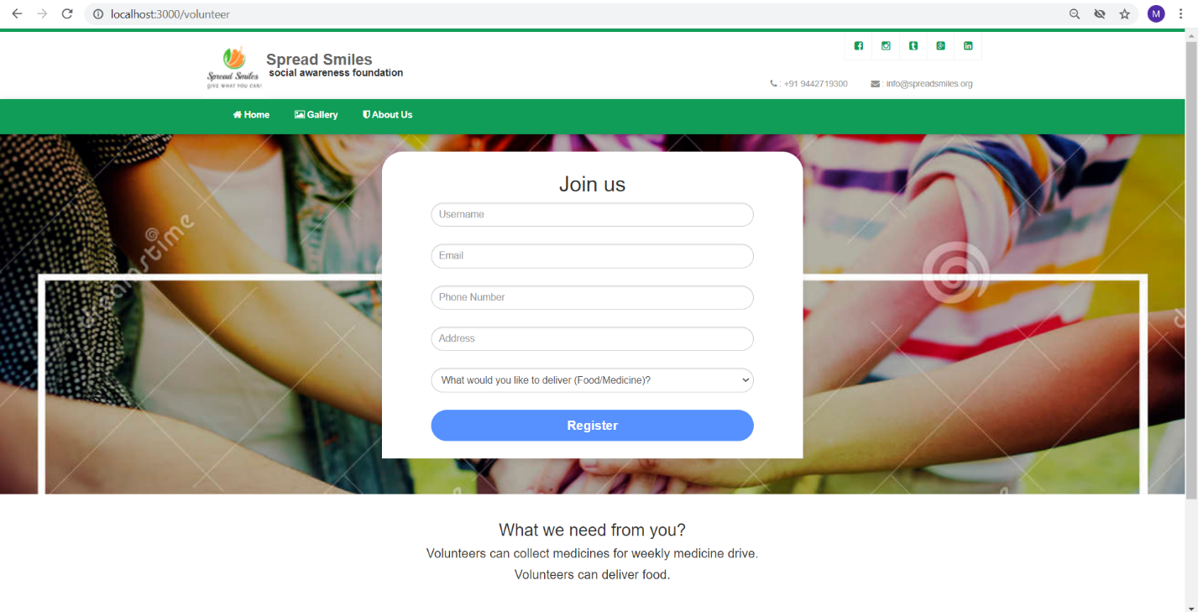

**6.11 Food deliveries**

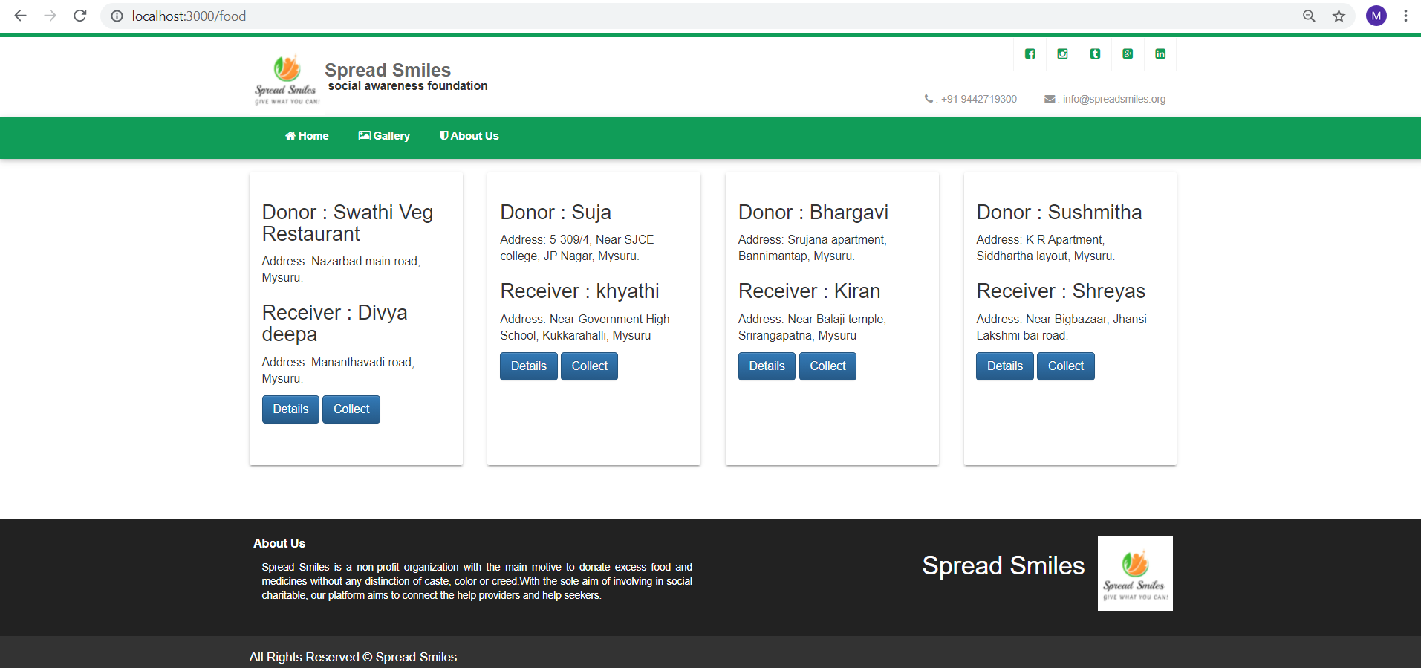

**6.12 Medicine deliveries**

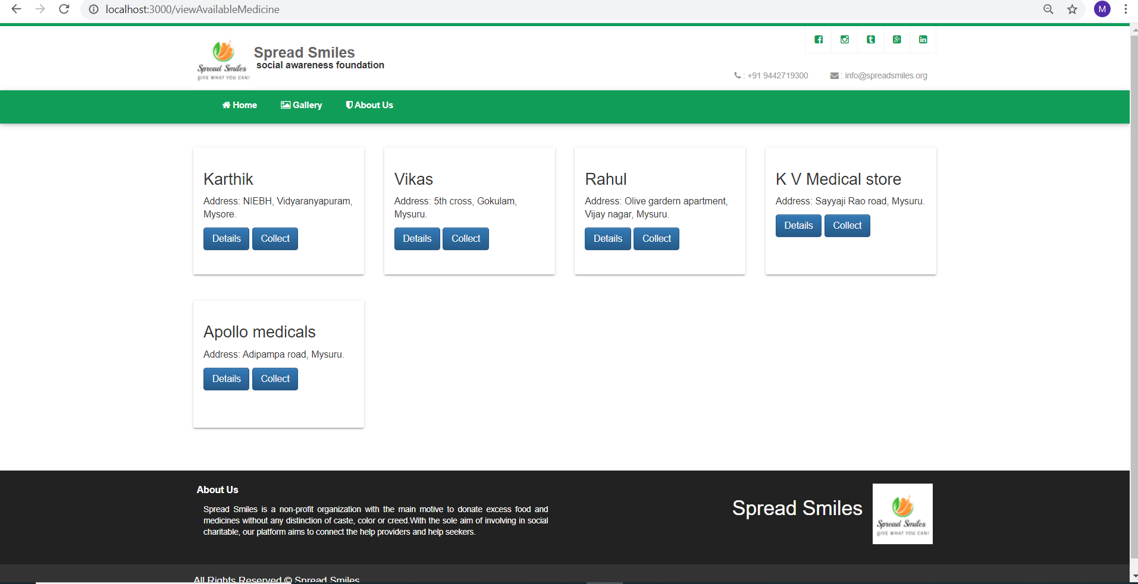

**6.13 Gallery-1**

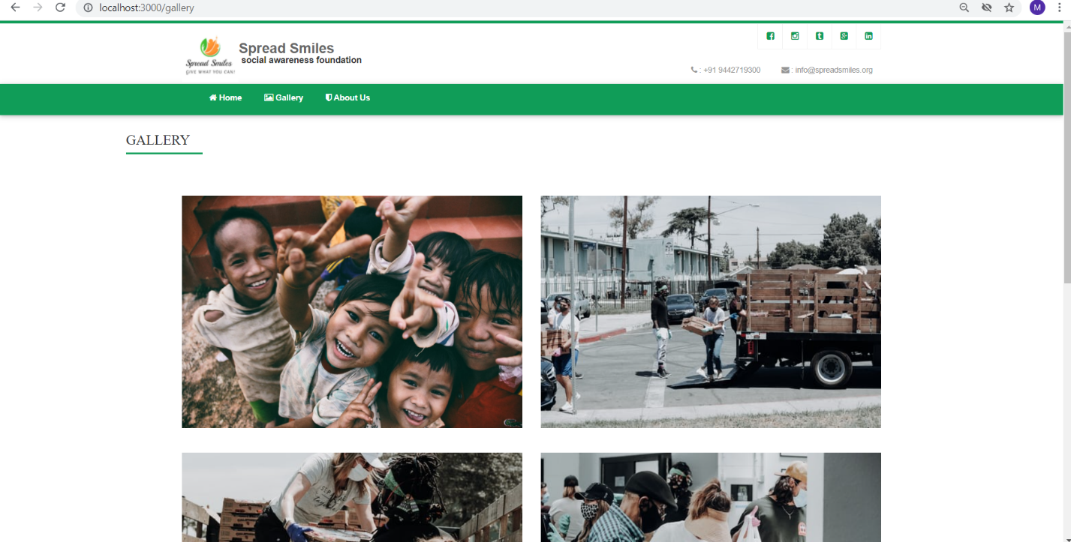

**6.14 Gallery-2**

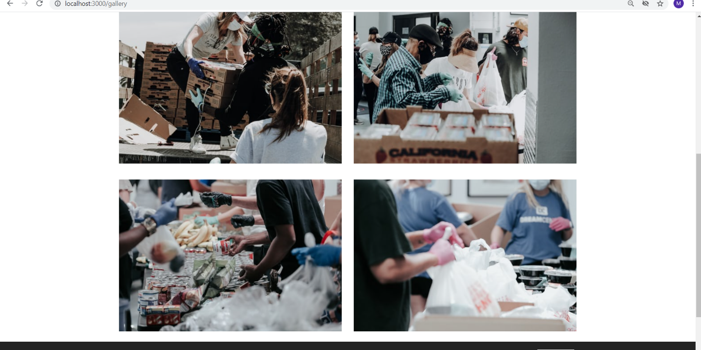

**6.15 About us-1**

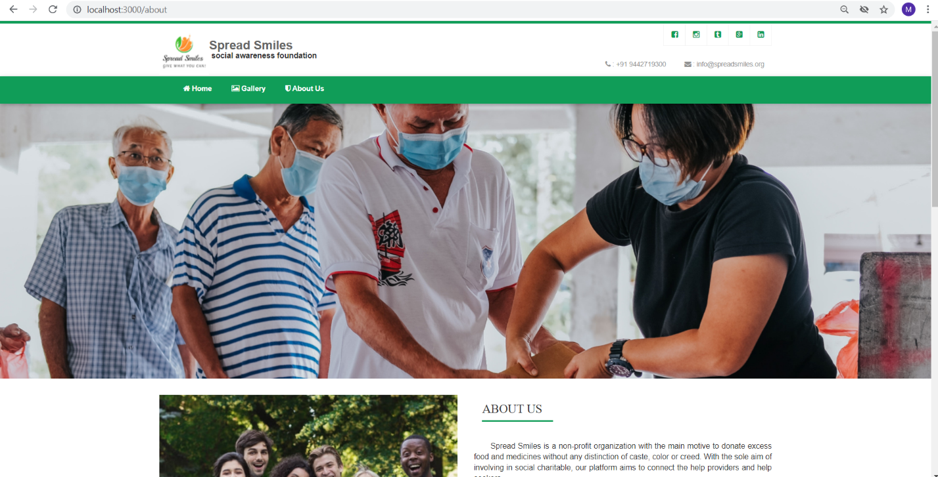

**6.16 About us-2**

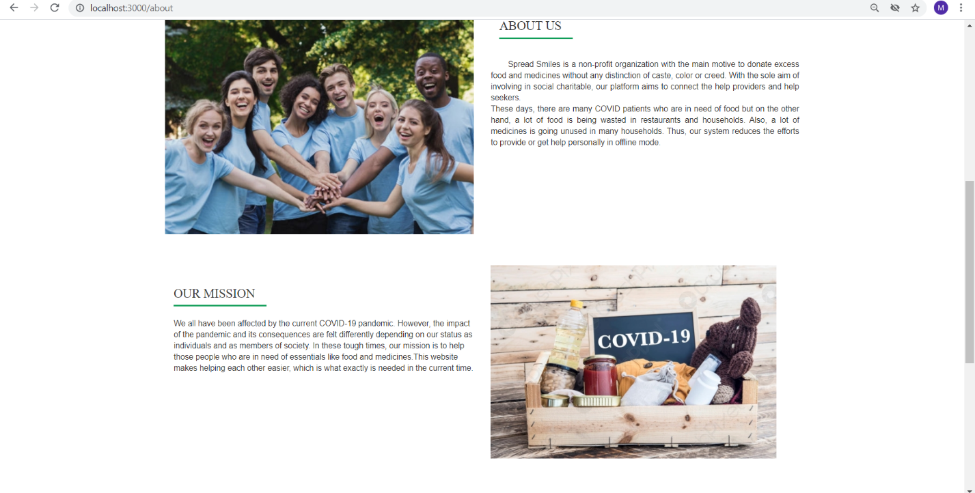

**6.17 About us-3**

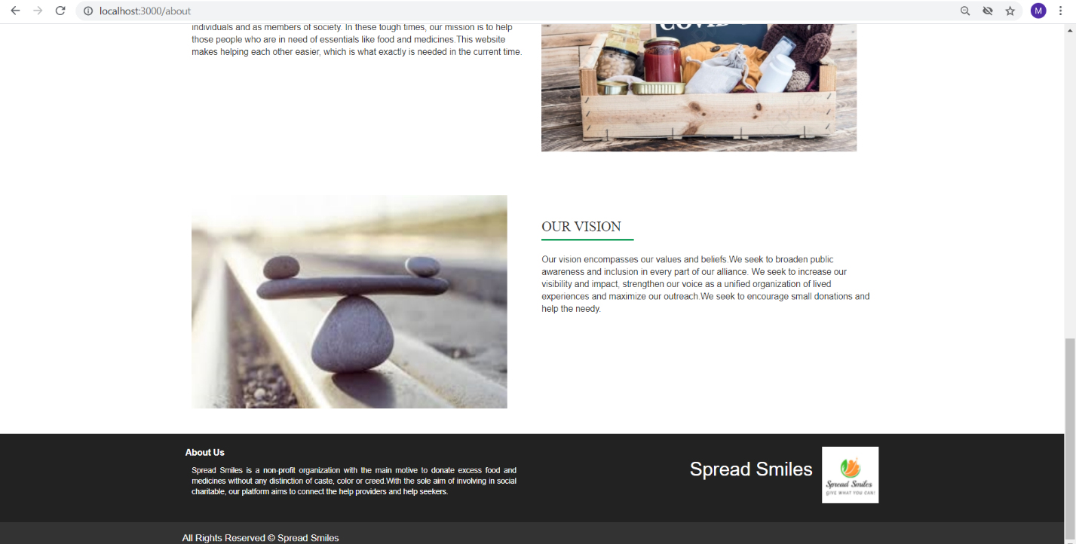

This page enables registered users to login and access the website.

**Conclusion and Future Enhancements**

**Conclusion:**

The COVID-19 pandemic has led to a dramatic loss of human life worldwide and presents an unprecedented challenge to public health, food systems and the world of work. The economic and social disruption caused by the pandemic is devastating. Only together can we overcome the intertwined health and social and economic impacts of the pandemic.

The objective of this project was to provide an effortless platform to everyone who wish to help and also for everyone who need help. This website is developed in such a way that it’s user friendly and easy to use. This website acts as an intermediate between donor and receiver, which makes the whole process easy. In this collective fight against COVID-19, no amount is small to make a difference. Our website will be easily accessible by everyone and all the donations on this website will be genuine and transparent. This website makes helping each other easier, which is what exactly is needed in the current time.

**Future Enhancements:**

We have successfully finished the development of our Food & Medicine donation system. There is always a room for improvement in any software, however efficient the system maybe, so we would like to improve our system in future. We would like to add some other features to our website to make it more user friendly. Our current system is website-based, we want to turn this system into Android application so that it will be more user friendly. Also, nowadays security is of major importance, so we would like to tighten up the security of our system.

We have implemented this project locally which can be extended to real time applications which has a greater use and using cloud technology also will increase the effectiveness of our project when dealing with large data sets.

**References**

Node.js:

[https://nodejs.dev/learn](https://nodejs.dev/learn%20)

HTML & CSS:

<https://www.w3schools.com/>

For other queries:

<https://stackoverflow.com/>

[https://www.tutorialspoint.com/](https://www.tutorialspoint.com/django/index.htm)

<https://www.javatpoint.com/>

https://www.guru99.com/node-js-mongodb.html

<https://simpleisbetterthancomplex.com/>

https://docs.mongodb.com/manual/tutorial/